**Registration Form**

For

State Level Workshop

On

**Women Empowerment**

March 8, 2017

Name …………………………………………

Designation………………………………..

Organization………………………………

Postal Address…………………………….

………………………………………………….

…………………………………………………

Phone No……………………………………

E-mail…………………………………………

Date: Signature

Registration before:

8th March 2017



Programme Schedule: 10.00 a.m.

***Address for Correspondence:***

PT. Sita Ram Shastri

B.ED Training College

Meham Gate, Bhiwani

**Contact No**. +917404201579

**Email:**

ptsrsb.edcollege@ymail.com

STATE LEVEL WORKSHOP

ON

***WOMEN EMPOWERMENT***

March 8, 2017

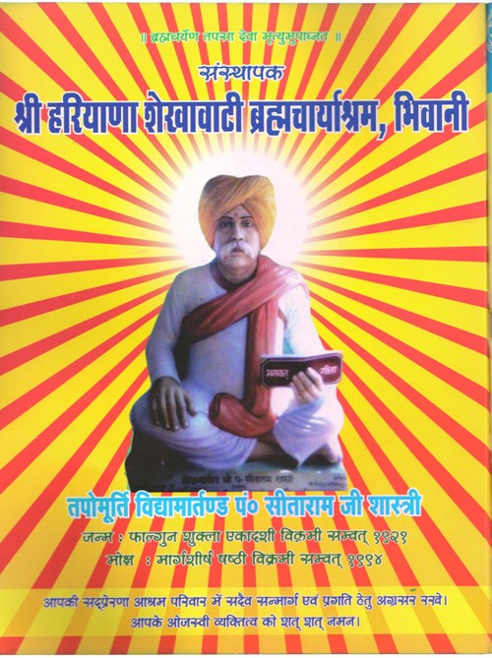

Organized by

*PT. SITA RAM SHASTRI B.ED TRAINING COLLEGE*

MEHAM GATE, BHIWANI

Recognized by NCTE, affiliated to

CRSU, Jind

PT. Sita Ram Shastri B.ED Training College is going to organize one day State Level Workshop is designed to introduce the role of Women and Status of women in Present Scenario. Women Empowerment is to empower women by promoting their participation in all areas and sectors to build stronger Economies, improve their qualities of life and bring gender equality.

Objectives:

1. Encouraging adequate respect and support Women.
2. To make women self dependent.
3. For gender equality.
4. To empower women.
5. To develop better civil society.
6. To improve the educational status of women.

**WOMEN EMPOWERMENT**



“TO Strengthening the social, economic and educational power of

Of Women”

**Resource Person**

Dr. Aparna Batra (Session-1)

Dr. Rashmi Bajaj (Session-1)

Dr. Sunita Arya (Session-2)

**Organizing Committee**

1. **Patron**

Sh. Shiv Parkash Sharma

1. **Convener**

Mr. Vikas Sharma

1. **Organizing Secretary**

Mrs. Rekha

Mrs. Monika Rani

1. **Members**

Mrs. Karishma

Mrs. Ranjana

Mrs. Santosh

Mr. Anil Kumar